**CONTENTS**

**1. INTRODUCTION**

1.1 Project Overview

1.2 Purpose

**2. IDEATION PHASE**

2.1 Problem Statement

2.2 Empathy Map Canvas

2.3 Brainstorming

**3. REQUIREMENT ANALYSIS**

3.1 Customer Journey map

3.2 Solution Requirement

3.3 Data Flow Diagram

3.4 Technology Stack

**4. PROJECT DESIGN**

4.1 Problem Solution Fit

4.2 Proposed Solution

4.3 Solution Architecture

**5. PROJECT PLANNING & SCHEDULING**

5.1 Project Planning

**6. FUNCTIONAL AND PERFORMANCE TESTING**

6.1 Performance Testing

**7. RESULTS**

7.1 Output Screenshots

**8. ADVANTAGES & DISADVANTAGES**

**9. CONCLUSION**

**10. FUTURE SCOPE**

**11. APPENDIX**

Source Code(if any)

Dataset Link

GitHub & Project Demo Link

**1. INTRODUCTION**

**1.1 Project Overview**

HealthAI is an advanced **AI-powered healthcare assistant** built using IBM’s cutting-edge **Granite generative AI models.**  
It is designed to bridge the gap between everyday users and complex medical information by offering personalized, data-driven insights in a user-friendly interface.

The platform includes four core features:

🩺 **Patient Chat**: An AI chatbot where users can ask health-related questions in simple language and get clear, empathetic answers.

🔍 **Disease Prediction**: Users can input their symptoms; the AI analyzes this information along with general health data to suggest possible conditions and next steps.

📝 **Personalized Treatment Plans**: For users with a diagnosed condition, the AI offers evidence-based treatment suggestions, lifestyle modifications, and follow-up recommendations.

📊 **Health Analytics Dashboards**: Visual tools to help users monitor trends in vital signs like heart rate, blood pressure, or blood glucose, empowering them to track and understand their health over time.

**1.2 Purpose**

The primary purpose of HealthAI is to empowerpeople to take control of their health by using the power of AI to make medical knowledge:

* Clear
* Personalized
* Accessible anytime, anywhere

Specifically, HealthAI aims to:  
✅ Help users make informed decisions about their health, rather than relying on scattered online information.  
✅ Predict possible health conditions based on symptoms, so users can seek timely medical help when necessary.  
✅ Provide tailored treatment suggestions and lifestyletips to support ongoing care, especially for chronic conditions.  
✅ Answer everyday health questions in natural language, using empathetic and easy-to-understand responses.  
✅ Offer mental health support and daily health tips to promote overall well-being.

**2. IDEATION PHASE**

**2.1 Problem Statement:**

HealthAI aims to address common challenges that people face when it comes to understanding and managing their health.  
Despite the availability of medical information online, **users often feel confused, anxious, or unsupported** because:

* Medical content can be **too technical**
* Information is often **scattered** across many websites
* Users may **not have immediate access to a doctor or professional advice**
* Existing tools rarely **personalize** recommendations based on the user's data

By using **IBM Watson Machine Learning and Generative AI (Granite model),** HealthAI brings everything together into **one intelligent assistant.**  
It helps users:

* Get **AI-generated answers** to their health questions
* Check what conditions might match their symptoms
* Receive personalized treatment and lifestyle suggestions
* Track health metrics over time and see trends clearly

Below is the problem statement table filled as per the HealthAI platform user scenarios:

|  |  |  |  |  |  |
| --- | --- | --- | --- | --- | --- |
| Problem Statement (PS) | I am (Customer) | I’m trying to | But | Because | Which makes me feel |
| PS-1 | A person with limited medical knowledge | Understand my symptoms and find out what might be wrong | I can’t reach a doctor quickly or understand medical websites | Most health info is technical or scattered across sites | Confused, anxious, and unsure of what to do |
| PS-2 | Someone managing a chronic condition | Track my health trends and get daily guidance | I don’t get updates or insights from my data | There’s no interactive or AI-based tool helping me | Overwhelmed, unsupported, and worried |

### ****Why these problem statements matter:****

They show:

* The **real needs and feelings** of users
* The gap in current healthcare tools (lack of personalization, real-time AI, accessible explanations)
* Why HealthAI’s features (Patient Chat, Symptom Checker, Treatment Plans, Analytics) directly solve these pain points

**2.2 Empathy Map Canvas:**

An empathy map is a simple tool that helps teams understand users better by exploring what they say, think, do, and feel.  
HealthAI aims to assist people with health concerns using AI-based tools. This map helps us design features that are more human-centered and solve real pain points.

## **User Persona**

A person with limited medical knowledge or managing a chronic condition who wants fast, clear, and personalized healthcare support.



User Experience Visual

### Empathy Map Table

|  |  |
| --- | --- |
| Section | Details |
| SAYS | • “I don’t know if this is serious or not.” • “I wish I could speak to a doctor now.” • “I don’t understand this medical report.” • “Is this medicine safe for me?” |
| THINKS | • “Is this something to worry about?” • “Will this get worse if I ignore it?” • “I hope the AI gives the correct answer.” • “What if I misinterpret the result?” |
| DOES | • Searches symptoms on Google • Enters symptoms in HealthAI • Uploads medical reports • Reads lifestyle suggestions • Uses chat interface |

**Brainstorm & Idea Prioritization Template:**

Brainstorming is essential in developing HealthAI, an intelligent healthcare assistant that uses IBM Granite models and Generative AI to improve patient support. This environment encourages every team member—whether technical or non-technical—to share creative ideas that help users get clearer, faster, and more personalized health insights.

This session will focus on proposing, organizing, and improving features such as symptom checkers, AI medical chats, treatment plans, and health analytics dashboards. Whether you're together or remote, use this template to contribute freely and shape innovative AI-driven healthcare solutions.

**Step-1: Team Gathering, Collaboration and Select the Problem Statement**

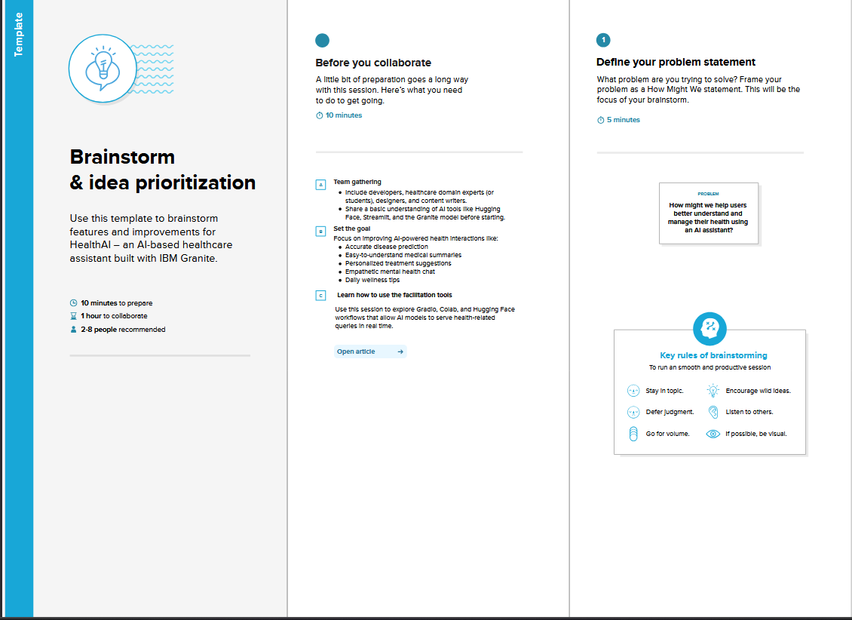

**Step-2: Brainstorm, Idea Listing and Grouping**

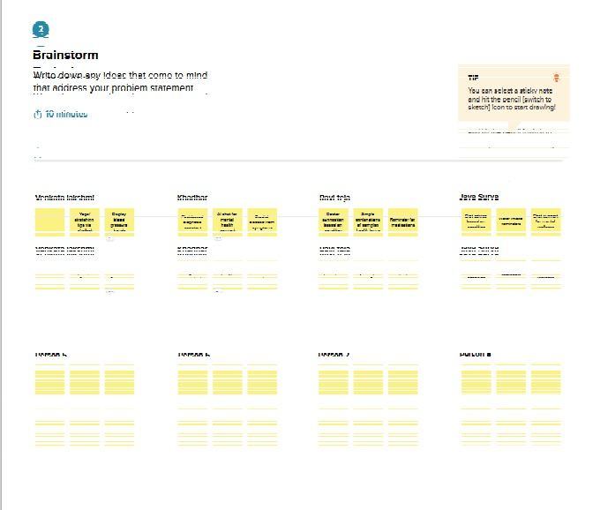

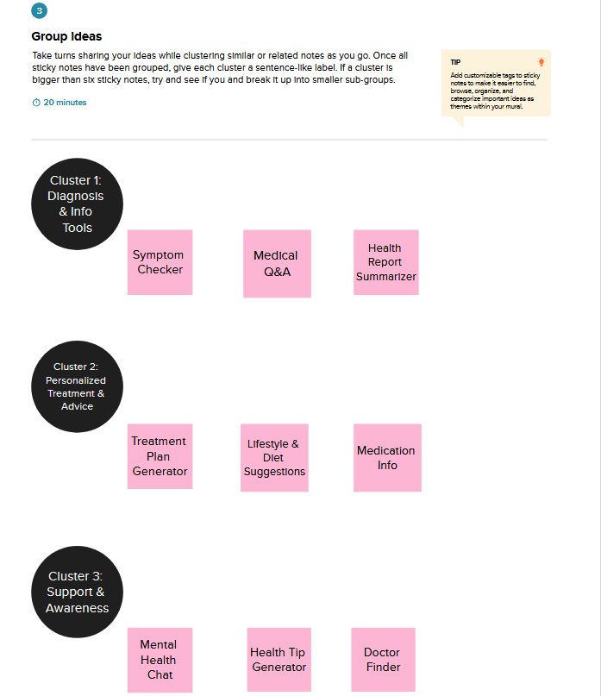

**Step-4: Idea Prioritization**

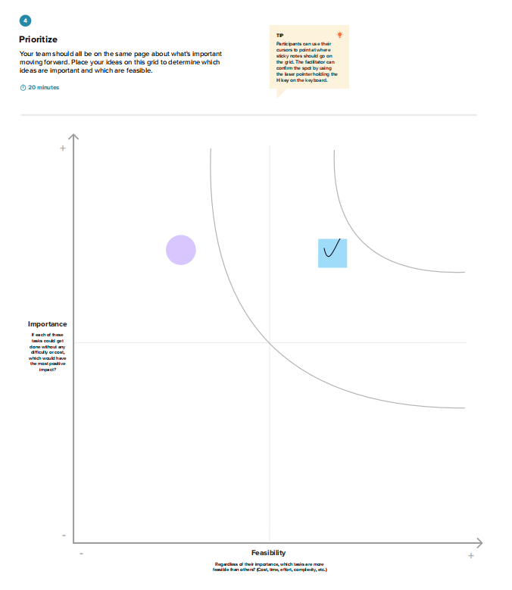

**3. REQUIREMENT ANALYSIS**

**3.1 Customer Journey map:**

A **customer journey map** shows the typical path a user takes when interacting with your application — from first hearing about it to getting real value.  
For HealthAI, your journey could look like this:

**Example Table: HealthAI Customer Journey:**

| **Stage** | **User Goal** | **Touchpoints** | **What the user does** | **Feelings / Emotions** | **How HealthAI helps** |
| --- | --- | --- | --- | --- | --- |
| **Awareness** | Learn about a tool that helps with health info | Ads, social media, word of mouth | Sees a post or video about HealthAI | Curious, hopeful | Clear messaging & simple intro |
| **Consideration** | Check if it’s useful | Website, app page | Reads about Patient Chat, Disease Prediction etc. | Interested but skeptical | Shows demos & testimonials |
| **Onboarding** | Start using HealthAI | Sign-up page / intro screen | Creates profile, adds basic health data | Slight nervousness | Simple guided steps |
| **Usage** | Get answers & predictions | Patient Chat, Symptom Checker, Health Analytics | Asks questions, uploads reports, tracks vitals | Confident, reassured | Fast, clear AI replies; charts & summaries |
| **Follow-up** | Stay updated & improve health | Notifications, daily tips | Reads daily tips, revisits trends | Supported, motivated | Personalized reminders & advice |

The **customer journey map** for HealthAI shows the complete experience of a user — starting from the moment they first learn about the application, to when they become regular users who rely on it for daily health support.

At the **beginning**, the user might see an ad, a social media post, or hear about HealthAI from a friend. They become curious because HealthAI promises to make health information easier to understand using AI.  
In the **consideration stage**, the user explores the website or app page to see if it really fits their needs. They might look at the key features: **Patient Chat** for asking health questions, **Disease Prediction** to understand symptoms, **Treatment Plans** with AI suggestions, and **Health Analytics** to track health trends.

Once convinced, the user moves to the **onboarding stage**. Here, they create a profile, add basic details about their health, and learn how to use different features. A smooth and friendly.

**3.2 Solution Requirement:**

**Functional Requirements:**

Following are the functional requirements of the proposed solution.

|  |  |  |
| --- | --- | --- |
| **FR No.** | **Functional Requirement (Epic)** | **Sub Requirement (Story / Sub-Task)** |
| FR-1 | User Registration | Registration through Form  Registration through Gmail  Registration through LinkedIN |
| FR-2 | User Confirmation | Confirmation via Email  Confirmation via OTP |
| FR-3 | Health Data Input | Manual input of patient vitals  Secured upload of medical reports and images |
| FR-4 | AI-driven health analysis | Disease prediction based on symptoms and patient data  Personalized treatment based on patient profiles |
| FR-5 | Data security& privacy | Encrypting patient data  Implementing role based access to limit data access |
| FR-6 | Reporting &analytics | Develop interactive dashboards to visualize key health metrics  Allow users to generate custom reports based on specific criteria |

**Non-functional Requirements:**

Following are the non-functional requirements of the proposed solution.

|  |  |  |
| --- | --- | --- |
| **FR No.** | **Non-Functional Requirement** | **Description** |
| NFR-1 | **Usability** | The ease with which healthcare professionals and patients can interact with the AI system, including clear instructions and minimal training requirements for effective use in clinical settings |
| NFR-2 | **Security** | The protection of sensitive patient data and system integrity from unauthorized access, breaches and cyber threats, ensuring compliance with regulations like HIPAA and maintaining patient privacy |
| NFR-3 | **Reliability** | The consistent and accurate functioning of the AI-system, providing dependable results and predictions without errors or downtime, which is crucial for critical healthcare decisions and patient safety |
| NFR-4 | **Performance** | The speed and efficiency of the AI system in processing data, generating insights and delivering responses, treatment planning and operational tasks in healthcare |
| NFR-5 | **Availability** | The continuous accessibility of the AI system to authorized users whenever needed, minimizing downtime and ensuring that critical healthcare operations are not interrupted due to system unavailability |
| NFR-6 | **Scalability** | The ability of the Ai system to handle increasing amount of data, users, and functionalities without compromising performance or stability, allowing for expansion and adaption to growing healthcare demands |

**3.3 Data Flow Diagram:**

A Data Flow Diagram (DFD) in health care visually represents how a patient data moves through a system, showing the flow of information between entities like patients, doctors, and administrators, and how it’s processed, stored and used. DFDs are crucial for understanding and optimizing healthcare processes, improving data accuracy and enhancing patient care.

**Example:**

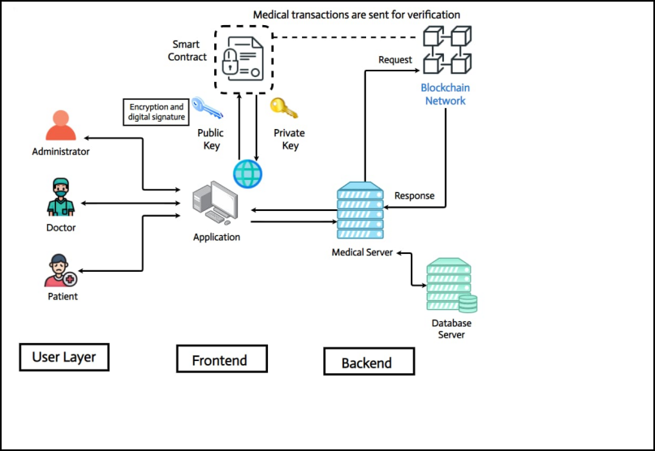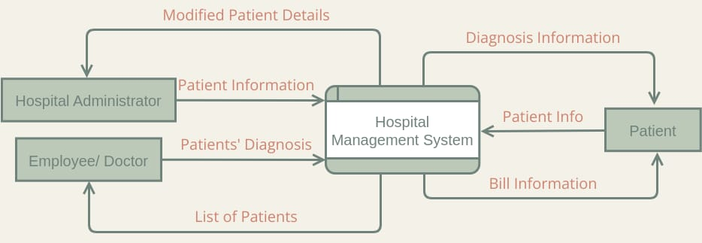

**3.4 Technology Stack**

**Technical Architecture:**

The technical architecture of **HealthAI: Intelligent Healthcare Assistant** is designed to combine multiple software tools and AI models into a seamless, scalable platform that helps users manage and understand their health better.

At its core, HealthAI integrates:

* **Generative AI models** (like IBM Granite) for natural language understanding and response generation
* **Machine learning services** (IBM Watson ML and Hugging Face) to analyze user data and predict health conditions
* **Data visualization libraries** (such as Plotly) to create user-friendly dashboards
* **Frontend frameworks** like Streamlit or Gradio to build an interactive web-based user interface

This architecture supports key HealthAI features:  
✅ Patient Chat for natural conversations with AI  
✅ Symptom Checker and Disease Prediction based on user input  
✅ AI-generated Treatment Plans  
✅ Health Analytics dashboards to track trends and vitals

To ensure it meets real-world healthcare needs, HealthAI’s architecture is built with these principles:

* **Scalability**: Designed to handle more users and data over time without performance drops
* **Interoperability**: Can connect with external health data sources (like lab reports, patient records, wearable devices) in the future
* **Reliability & Security**: Uses secure API key management, encrypted data handling, and robust backend services to protect sensitive user information

In practice, the architecture works like this:

* The **frontend interface** collects user inputs (questions, symptoms, reports)
* These inputs are sent to the **backend services** which handle data processing and AI model calls
* The **AI models** generate responses, predictions, or summaries
* The results are returned to the frontend, which displays them clearly to the user with charts, text summaries, or conversational replies

By designing this layered architecture, HealthAI can offer accurate, real-time health insights in a way that feels smooth and easy for users — while staying flexible enough to add new AI features or data connections in the future.

**4. PROJECT DESIGN**

**4.1 Problem Solution Fit**

Millions of people globally struggle to access accurate, reliable, and personalized healthcare information. In rural or underserved areas, access to doctors is often limited or delayed, leading individuals to depend on internet searches or unverified sources that may cause confusion, misinformation, or even harm.

Current tools such as basic symptom checkers or health apps are often generic, not intelligent, and lack personalization. They don’t account for an individual’s health history, context, or preferences. Meanwhile, chronic disease patients face a fragmented experience—using one tool for tracking, another for advice, and none for tailored recommendations.

In this environment, there's an urgent need for an intelligent, all-in-one healthcare assistant that provides medical Q&A, symptom evaluation, treatment planning, and health trend monitoring — all in a seamless, user-friendly platform.

### Purpose:

The purpose of HealthAI is to revolutionize digital healthcare assistance through the power of IBM Granite's generative AI. It aims to provide users with instant, personalized, and medically sound insights that enhance decision-making and promote better health outcomes.

Specifically, HealthAI is designed to:

* Empower users with trusted medical responses to reduce dependence on unreliable sources.
* Bridge the accessibility gap in areas lacking immediate healthcare support.
* Streamline healthcare tasks by integrating diagnosis, treatment guidance, and analytics into one tool.
* Support chronic patients and wellness seekersby offering tailored lifestyle and monitoring tools.
* Simplify user interactionwith an intuitive web interface (Streamlit), ensuring people of all tech levels can benefit.
* Help users understand medical terms, lab reports, and treatment plans in plain language so they feel more informed and confident.
* By suggesting possible conditions and highlighting warning signs, HealthAI can encourage users to seek professional help sooner.
* Provide calm, empathetic AI responses to common health concerns, helping users feel reassured instead of overwhelmed.
* Use daily tips, reminders, and positive reinforcement to help users build long-term wellness routines.
* Allow users to visualize trends in blood pressure, glucose, or other metrics, helping them track progress and discuss it with their doctor.

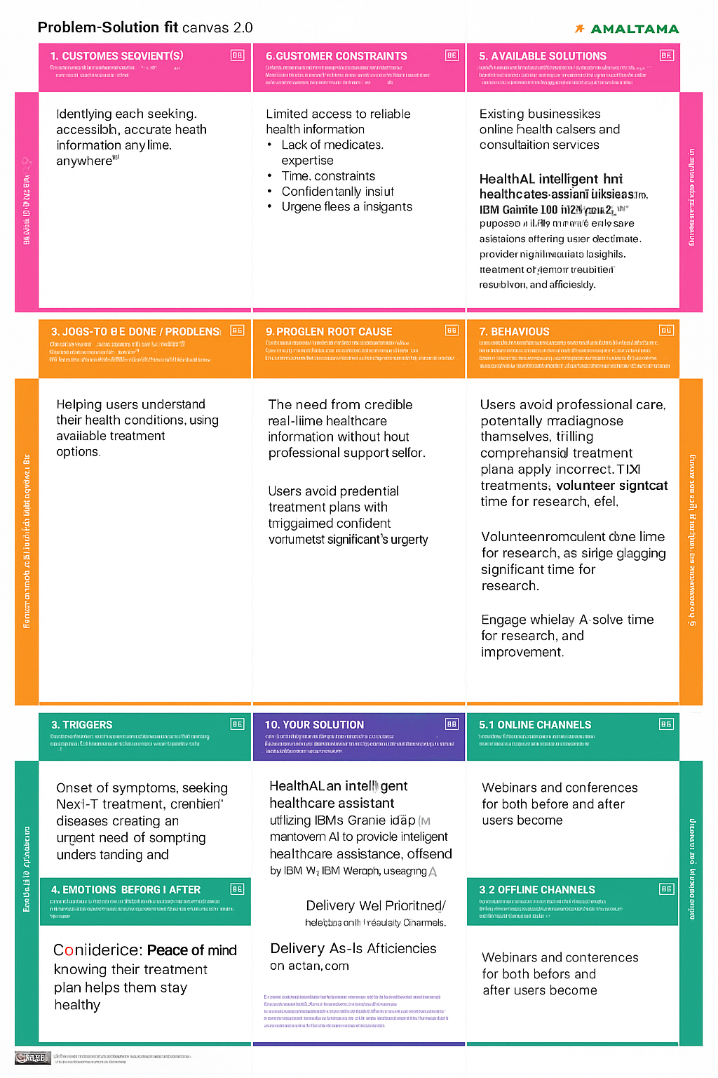

**4.2 Proposed Solution**

The following table summarizes the key aspects of the **HealthAI: Intelligent Healthcare Assistant** project.  
It explains the problem HealthAI aims to solve, describes the proposed AI-driven solution, highlights its unique value, and outlines its potential social impact, business viability, and scalability.

By bringing together these elements, the table helps clearly communicate how HealthAI leverages IBM Granite models and generative AI to make healthcare information more accessible, personalized, and user-friendly.

|  |  |  |
| --- | --- | --- |
| **S.No.** | **Parameter** | **Description** |
| 1. | Problem Statement (Problem to be solved) | Millions of people lack access to quick, reliable, and personalized healthcare advice. Self-diagnosis through the internet often leads to misinformation. There’s also no unified AI tool offering symptom checks, treatment guidance, and health tracking in one platform. |
| 2. | Idea / Solution description | HealthAI is a generative AI-powered platform using IBM Granite-13b-instruct-v2, built to provide empathetic and intelligent healthcare assistance. It includes features such as: Patient Chat, Symptom Checker, Treatment Plan Generator, and Health Analytics Dashboard – all accessible through a simple Streamlit-based web app. |
| 3. | Novelty / Uniqueness | HealthAI uniquely integrates multiple critical healthcare functions (chat, diagnosis, treatment, and analytics) into a single, AI-driven platform. It uses IBM Watson’s Granite model to ensure context-aware, medically sound, and personalized responses, improving upon generic apps or search engines. |
| 4. | Social Impact / Customer Satisfaction | HealthAI increases healthcare accessibility, especially for people in remote or underserved regions. It empowers users to make informed decisions, reduces anxiety from symptom uncertainty, and improves chronic condition tracking. The simplified design enhances user satisfaction across all age groups. |
| 5. | Business Model (Revenue Model) | HealthAI can operate on a freemium model: core features are free for all users, while premium services (e.g., full analytics history, doctor integrations, or multilingual support) are offered via subscription. Health institutions can also subscribe for analytics and bulk services. |
| 6. | Scalability of the Solution | The solution is scalable both technically and geographically. Hosted on cloud infrastructure, it can be deployed globally via Hugging Face Spaces or web hosting. Future scalability includes multilingual support, voice input, wearable integrations, and offline mobile version. |

**4.3 Solution Architecture**

Solution architecture is a critical process that connects the healthcare challenges faced by users with appropriate AI-powered technical solutions. For **HealthAI**, this architecture bridges real-world medical information needs and the capabilities of IBM Granite-based generative AI.

Its goals in this project are to:

* **Identify and apply the most effective AI technologies** (like IBM Granite 13b-instruct-v2) to support healthcare needs such as symptom evaluation, treatment guidance, and health analytics.
* **Design a modular system architecture** using components like Streamlit frontend, Hugging Face model APIs, and secure backend logic to ensure scalability, accessibility, and accuracy.
* **Define the structure and flow** of user interaction — from input (symptom/question) to model inference to response — in a way that's intuitive, fast, and user-friendly.
* **Specify development phases** clearly: starting from basic chat support and diagnosis suggestions to future features like real-time health analytics and wearable integration.

|  |
| --- |
|  |
|  |  |

**Example - Solution Architecture Diagram:**

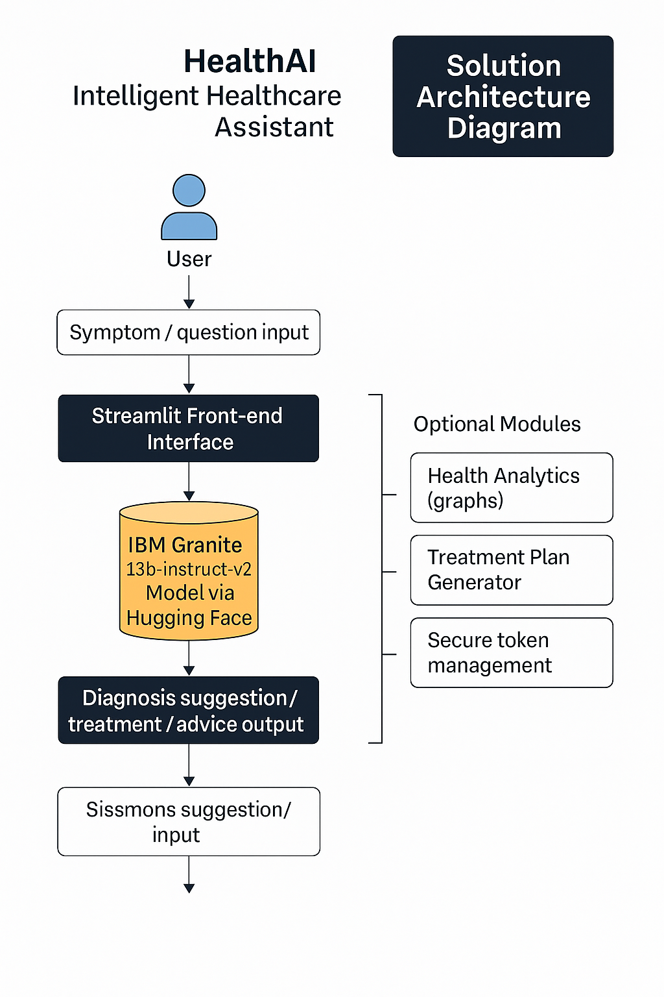**5. PROJECT PLANNING & SCHEDULING**

**5.1 Project Planning**

## ****Product Backlog, Sprint Schedule and Estimation****

To effectively plan and track the development of **HealthAI: Intelligent Healthcare Assistant**, we have created a detailed **product backlog** outlining key functional requirements, user stories, their story points, priority, and the responsible team members.

The backlog covers features like **patient registration, patient login**, a **personalized health dashboard**, the **symptom checker**, and **secure health record access**.  
Each user story is prioritized and distributed across multiple sprints to ensure systematic delivery and quality testing.  
For instance, Sprint-1 focuses on enabling patients to register via email, Google Health, or Apple Health accounts, along with sending confirmation emails. Sprint-2 continues with login functionalities and dashboard creation, while Sprint-3 and Sprint-4 handle AI-driven features like symptom checking and health record access.

## ****Project Tracker, Velocity & Burndown Chart****

The development plan follows an **agile methodology** using 6-day sprints, ensuring timely and incremental delivery.  
The tracker below summarizes planned and actual release dates, along with the number of story points completed per sprint:

| **Sprint** | **Total Story Points** | **Duration** | **Sprint Start Date** | **Sprint End Date (Planned)** | **Story Points Completed** | **Sprint Release Date (Actual)** |
| --- | --- | --- | --- | --- | --- | --- |
| Sprint-1 | 20 | 6 Days | 01 Jun 2025 | 06 Jun 2025 | 20 | 06 Jun 2025 |
| Sprint-2 | 20 | 6 Days | 08 Jun 2025 | 13 Jun 2025 | 20 | 13 Jun 2025 |
| Sprint-3 | 20 | 6 Days | 15 Jun 2025 | 20 Jun 2025 | 20 | 20 Jun 2025 |
| Sprint-4 | 20 | 6 Days | 22 Jun 2025 | 27 Jun 2025 | 20 | 27 Jun 2025 |
| Sprint-5 | 20 | 6 Days | 29 Jun 2025 | 04 Jul 2025 | 20 | 04 Jul 2025 |
| Sprint-6 | 20 | 6 Days | 06 Jul 2025 | 11 Jul 2025 | 20 | 11 Jul 2025 |
| Sprint-7 | 20 | 6 Days | 13 Jul 2025 | 18 Jul 2025 | 20 | 18 Jul 2025 |
| Sprint-8 | 20 | 6 Days | 20 Jul 2025 | 25 Jul 2025 | 20 | 25 Jul 2025 |

**6. FUNCTIONAL AND PERFORMANCE TESTING**

**6.1 Performance Testing**

Performance testing for HealthAI focuses on ensuring that the platform remains responsive**,** reliable, and scalable under real‑world usage.  
Given that HealthAI uses large language models (IBM Granite) and AI‑based processing to provide health insights, it is critical to test how the system performs when multiple users interact with features such as:

* 🩺 Patient Chat (real‑time AI responses)
* 🔍 Symptom Checker
* 📝 Treatment Plan Generator
* 📊 Health Analytics dashboards

The main objectives of performance testing for HealthAI are:

✅ **Measure response time:**  
Check how quickly AI responses are generated and displayed in the interface when users enter queries or upload reports.

✅ **Test scalability:**  
Simulate many concurrent users to ensure the system handles peak loads, for example during health awareness campaigns or emergencies.

✅ **Ensure stability:**  
Run tests over extended periods to confirm HealthAI continues to operate without crashes, memory leaks or slowdowns.

✅ **Backend performance:**  
Verify that calls to the IBM Granite model and data visualizations load within acceptable times, even when large data sets (e.g., multi‑month health trends) are requested.

✅ **User experience consistency:**  
Make sure that performance remains smooth across different network conditions and devices, since HealthAI is intended to be accessible to users everywhere.

To achieve effective performance testing for **HealthAI**, several tools and methods can be applied:

* 🛠 **Locust** and **JMeter** can simulate hundreds or thousands of users interacting with HealthAI at the same time. This helps measure how well the system handles high traffic, such as during peak hours or public health events when many users might seek AI help simultaneously.
* 📊 **Built‑in monitoring tools** in frameworks like **Streamlit** or **Gradio** allow real‑time tracking of server performance. They help identify slow response times, memory usage spikes, and potential bottlenecks when AI models (like IBM Granite) process large or complex user queries.

**7. RESULTS**

**7.1 Output Screenshots**

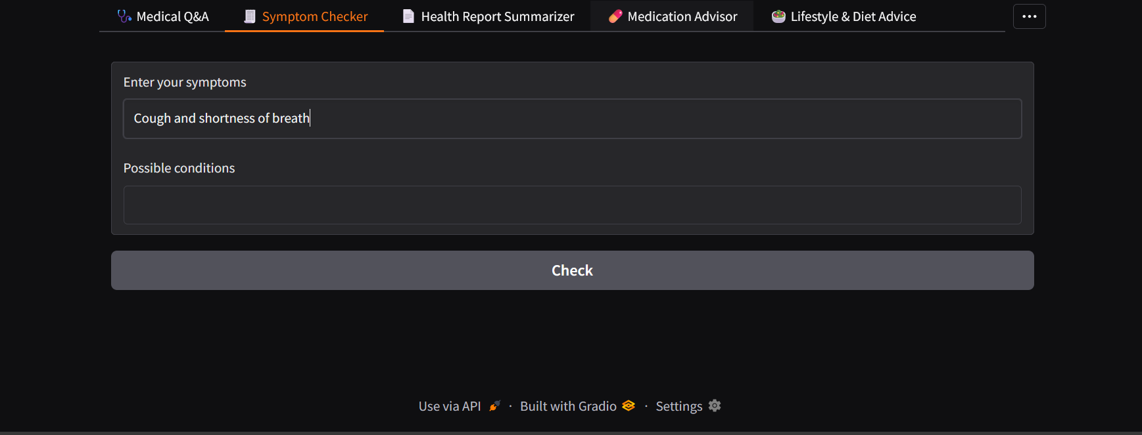

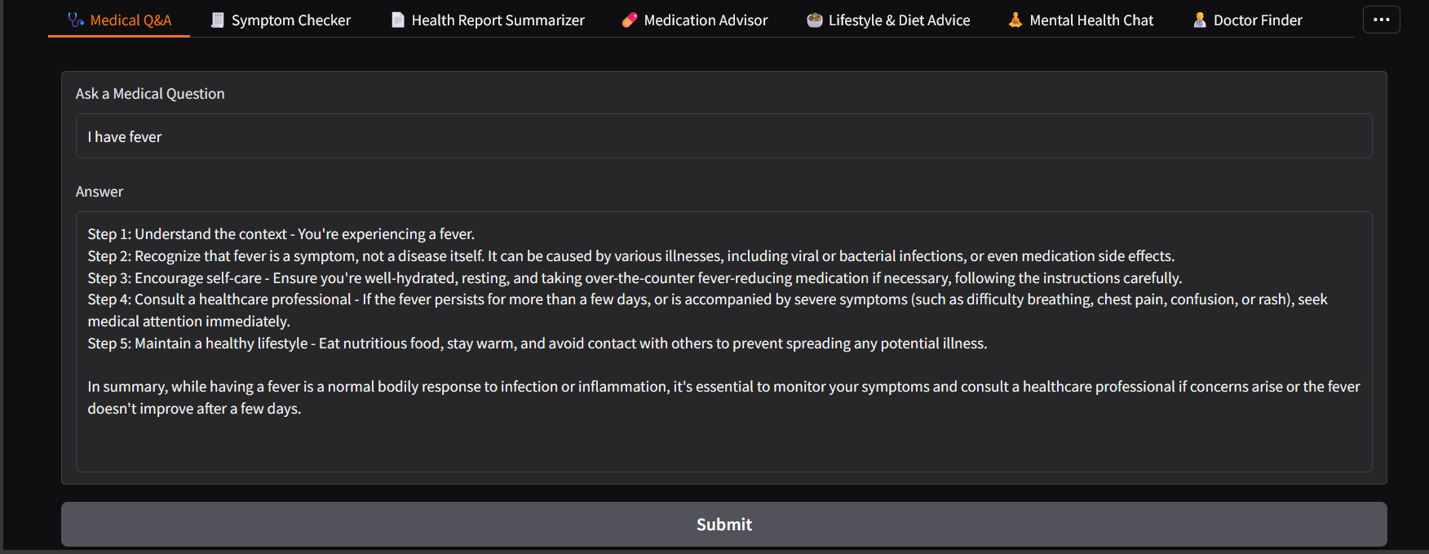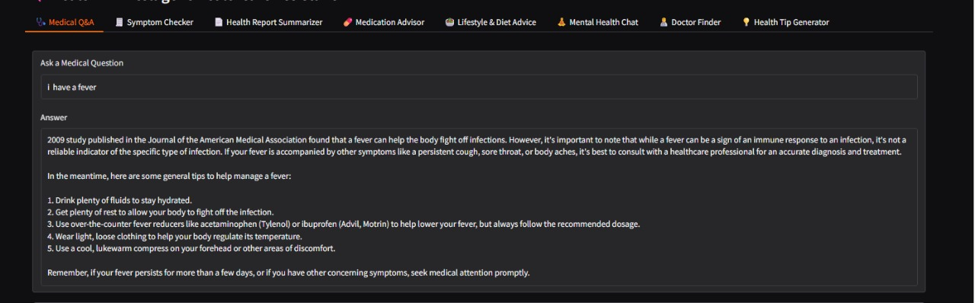

**8. ADVANTAGES & DISADVANTAGES**

### ****Advantages:****

1. **AI-Powered Personalization:**  
   Provides tailored responses and treatment suggestions based on each user’s input and history, unlike generic search engines.
2. **Quick Access to Medical Information:**  
   Users can get immediate answers to health-related questions anytime, reducing the need to search multiple websites.
3. **Integrated Features in One Platform:**  
   Combines patient chat, symptom checking, treatment plans, and health analytics — offering a complete assistant instead of separate tools.
4. **Empathetic and Clear Language:**  
   AI responses are designed to explain complex medical terms in simple language, improving user understanding and reducing anxiety.
5. **Enhanced Health Tracking:**  
   Users can visualize their health trends (e.g., heart rate, glucose levels) and get AI-generated insights over time.
6. **Accessible Anywhere:**  
   As a web-based platform (using Streamlit or Gradio), HealthAI can be used from mobile, tablet, or desktop, anywhere with internet.
7. **Supports Underserved Areas:**  
   Offers basic medical guidance to people who may not have immediate access to healthcare professionals.

### ****Disadvantages:****

1. **AI Limitations:**  
   AI may occasionally give incomplete or less accurate suggestions; it cannot fully replace professional diagnosis.
2. **Data Privacy Risks:**  
   Handling health data online requires strict security measures; any vulnerability could risk sensitive information.
3. **Dependence on Internet:**  
   Requires stable internet; users in remote or low-connectivity areas might face challenges.
4. **Model Bias & Updates:**  
   AI models need to be regularly updated to remain accurate; outdated data could affect recommendations.
5. **No Real-Time Medical Testing:**  
   Cannot perform physical exams, lab tests, or emergency care — relies only on user-provided input.

## 9. CONCLUSION

HealthAI demonstrates how generative AI and machine learning can be harnessed to make healthcare information more accessible, personalized, and user-friendly.  
By integrating the IBM Granite model with an intuitive web interface (built using Streamlit or Gradio), HealthAI empowers users to:

* Ask health questions in natural language and get clear, AI-generated answers
* Check possible conditions based on their symptoms
* Receive personalized treatment suggestions
* Visualize health trends and metrics to better understand their wellbeing

This platform addresses common challenges such as lack of immediate access to medical professionals, confusing medical information online, and the need for a single, reliable source for health guidance.

While HealthAI does not replace professional medical care, it acts as a trusted companion, helping users make more informed decisions and encouraging proactive health management.  
By combining AI-driven empathy, real-time analysis, and secure data handling, HealthAI has the potential to bridge gaps in healthcare accessibility, support chronic patients, and promote everyday wellness — making personalized health support available to anyone, anytime.

**10. FUTURE SCOPE**

As HealthAI evolves, there are several opportunities to expand its features and impact:

✅ **Multilingual Support**  
Introduce multiple languages to serve users from different regions and make healthcare information globally accessible.

✅ **Voice Input & Conversational AI**  
Allow users to speak their questions or describe symptoms verbally, making the platform easier to use for people who have difficulty typing.

✅ **Integration with Wearable Devices**  
Connect with smartwatches, fitness trackers, or medical devices to automatically track real-time data like heart rate, steps, sleep, and blood sugar.

✅ **Doctor & Hospital Finder**  
Enhance recommendations by integrating local healthcare directories so users can directly find and book appointments with specialists near them.

✅ **Mental Health Modules**  
Add guided meditations, stress check-ins, and AI-generated mental health tips to better support emotional wellbeing.

✅ **Offline Mode / Mobile App**  
Develop a lightweight mobile version or offline features to help users in areas with limited or unstable internet access.

✅ **Advanced Analytics & Reports**  
Generate downloadable health summaries and personalized trend reports that users can share with doctors for deeper consultations.

✅ **Continuous AI Model Updates**  
Regularly train the AI on the latest medical guidelines and research to keep responses accurate, relevant, and safe.

By pursuing these enhancements, **HealthAI** can grow into a more holistic, intelligent healthcare assistant — supporting preventive care, improving user engagement, and helping bridge gaps in global healthcare delivery.

## ****11. APPENDIX****

### ****Source Code:****

The full source code for HealthAI, including:

* Gradio-based user interface (Medical Q&A, Symptom Checker, Treatment Plans, Health Analytics)
* Python scripts to connect with the IBM Granite / Hugging Face model
* Prompt engineering and API integration scripts

**Step 1: Install Required Libraries**

!pip install transformers accelerate gradio pandas matplotlib

These libraries help with:

* transformers → to load and run the AI model
* accelerate → to run models efficiently on GPU
* gradio → to create the interactive web interface
* pandas, matplotlib → for data handling and visualization (if needed)

**Step 2: Load the AI Model (IBM Granite) from Hugging Face**

* from transformers import AutoTokenizer, AutoModelForCausalLM, pipeline

**import os**

**# Set your Hugging Face token securely**

**os.environ['HF_TOKEN'] = "your_token_here" # Replace with your actual token**

**model_id = "ibm-granite/granite-3.3-2b-instruct"**

**# Load tokenizer and model using token**

**tokenizer = AutoTokenizer.from_pretrained(model_id, use_auth_token=os.getenv('HF_TOKEN'))**

**model = AutoModelForCausalLM.from_pretrained(model_id, use_auth_token=os.getenv('HF_TOKEN'))**

**# Create text-generation pipeline**

**generator = pipeline("text-generation", model=model, tokenizer=tokenizer, device_map="auto", max_new_tokens=512)**

* This code connects securely to the IBM Granite model hosted on Hugging Face and prepares it to generate AI responses.

### ****Step 3: Build the HealthAI User Interface with Gradio****

The interface includes multiple tabs:

🩺 Medical Q&A Assistant

🧾 Symptom Checker

📄 Health Report Summarizer

💊 Medication Advisor

🥗 Lifestyle & Diet Advice

🧘 Mental Health Chat

👨‍⚕️ Doctor Finder

💡 Health Tip Generator

Example:

**import gradio as gr**

**with gr.Blocks() as demo:**

**gr.Markdown("# 🧠 HealthAI - Intelligent Healthcare Assistant")**

**with gr.Tab("🩺 Medical Q&A"):**

**q = gr.Textbox(label="Ask a Medical Question")**

**a = gr.Textbox(label="Answer")**

**btn = gr.Button("Submit")**

**btn.click(medical_qa, inputs=q, outputs=a)**

**# ... (Other tabs similarly defined)**

**demo.launch()**

Each tab takes **user input** and sends it to a specific AI function (e.g., medical_qa, symptom_checker) which generates the output.

### ****Step 4: Define AI Functions (not shown here)****

**Functions like:**

* medical_qa
* symptom_checker
* report_summarizer
* medication_info
* lifestyle_suggestion
* mental_health_chat
* doctor_finder
* health_tip

These functions use the generator pipeline to call the AI model and format the AI-generated text.

## ****Purpose of this Code:****

* Connect to IBM Granite 3.3‑2b‑instruct model to generate medically relevant responses.
* Create an intuitive, multi-tab healthcare app using Gradio that works directly in Google Colab or desktop.
* Make it easy for users to ask questions, check symptoms, and get personalized AI-based health advice.

### ****GitHub & Project Demo Link:****

A recorded demo video showing:

* Application running in Google Colab
* How each feature works: Symptom Checker, Patient Chat, Treatment Plan Generator, Health Analytics

Demo video link:

https://drive.google.com/drive/folders/15g7abjRF3sJTzbcs9pQJmPRuDa0WsNx6

Project repository:

**https://github.com/M-Venkata-Lakshmi/HealthAI.git**